Landscape Stories
Directions: Pass one picture out to each group. The group should decide what helped to shape the landscape in the photo. Each group should choose one person to represent them in front of the class to tell about their landscape photo. It is best to print these in color.

Badwater
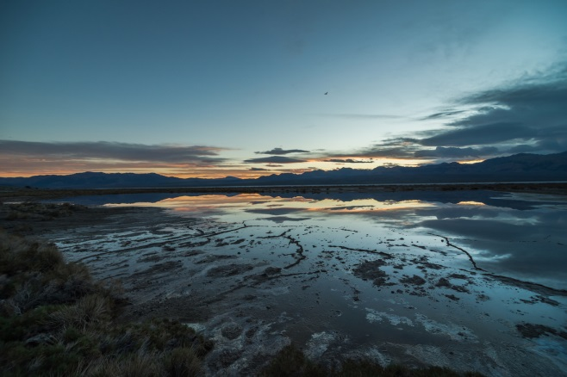
Photo credit NPS/Kurt Moses

Natural Bridge
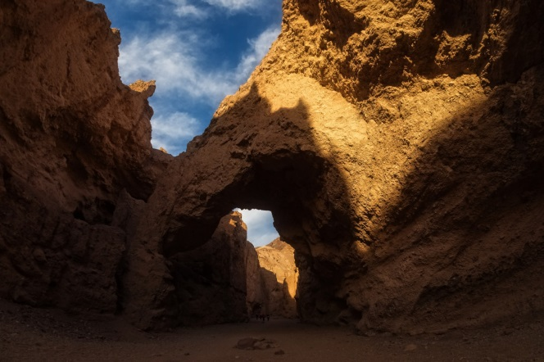
Photo credit NPS/Kurt Moses

Golden Canyon
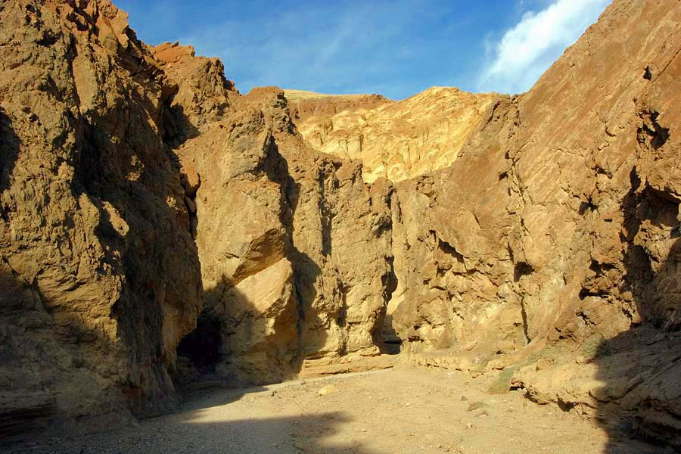
Photo credit NPS/Kurt Moses

